Portfolio Submission:
Runtime Analysis:
The first 3 charts will be the runtime for reading the data, while reading the data is also saving the data to a data structure.
Vectors:
Code | Line Cost | Execution Times | Total Cost
Reading data from file | 1 | n | n
Saving to class object | 1 | n | n
Saving to vector | 2 | n | n
Prerequisites? | 1 | 1 | 1
 |  | Total Cost: | 5n+1
 |  | Runtime | O(n)

Hash Table:
Code | Line Cost | Execution Times | Total Cost
Reading data from file | 1 | n | n
Saving to class object | 1 | n | n
Saving to Table | 6 | n | n
Prerequisites? | 1 | 1 | 1
 |  | Total Cost: | 9n+1
 |  | Runtime | O(n)

BST:
Code | Line Cost | Execution Times | Total Cost
Reading data from file | 1 | n | n
Saving to class object | 1 | n | n
Saving to BST | 2 | n | n
Prerequisites? | 1 | 1 | 1
 |  | Total Cost: | 5n+1
 |  | Runtime | O(n)

Alphanumeric Sort:
- Class Overload:
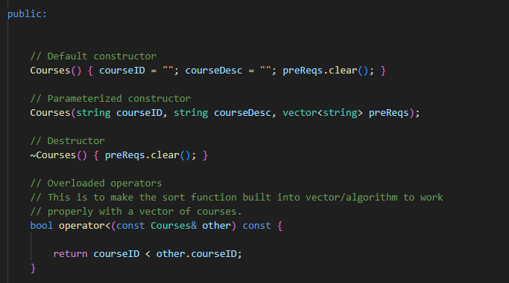
- Sort Portion:
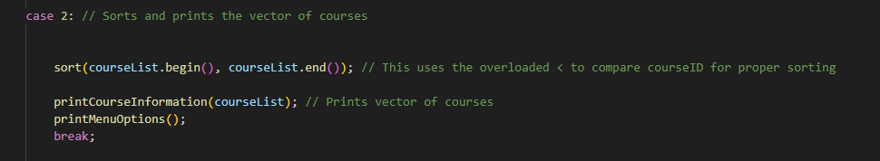
- Print Portion:
